|  |
| --- |
|  |
| Performance Testing Mentoring Program 2020#1  Task 2 report |

Contents

1. Summary 3

2. Actions 3

2.1. Test run#1 – 100 articles generation 3

2.2. Test run#2 – 1000 articles generation 9

2.3. Test run#2 – 2000 articles generation 14

3. Conclusion 16

# Summary

Was created the script to generate test posts(100,1000,2000) with any text from 50 to 1000 characters long.

# Actions

Run parameters (1 thread, rump-up period 10s). JMeter project + report is [here](https://github.com/diNovitska/BlogEngine/tree/master/TASK2). For 100 posts dates set from the list of particulate dates. For other posts dates generates randomly.

## Test run#1 – 100 articles generation

* ***Server metrics for that time period***

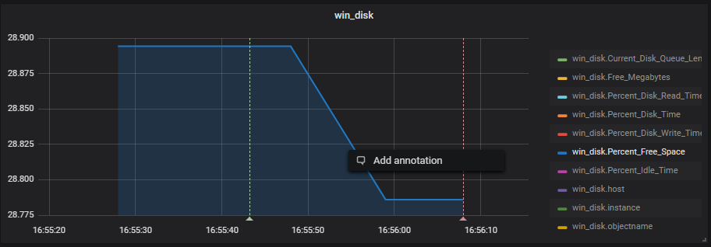

Free space on disk

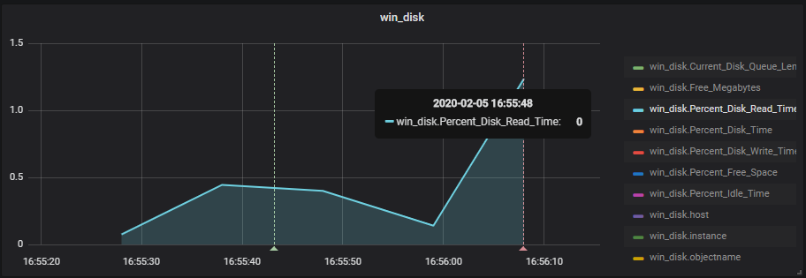

Disk metric - read time

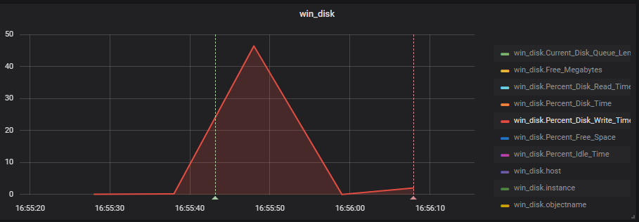

Disc metric – Write time

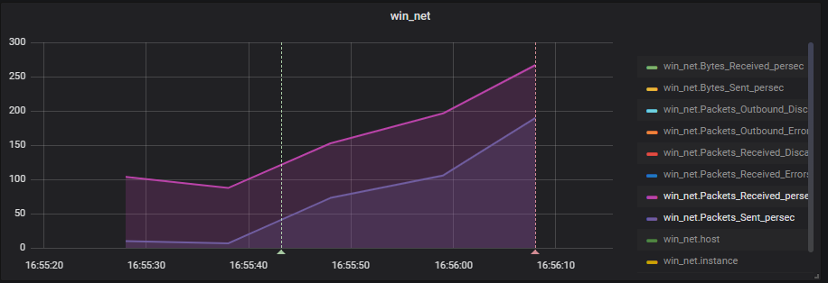

Packets metrics

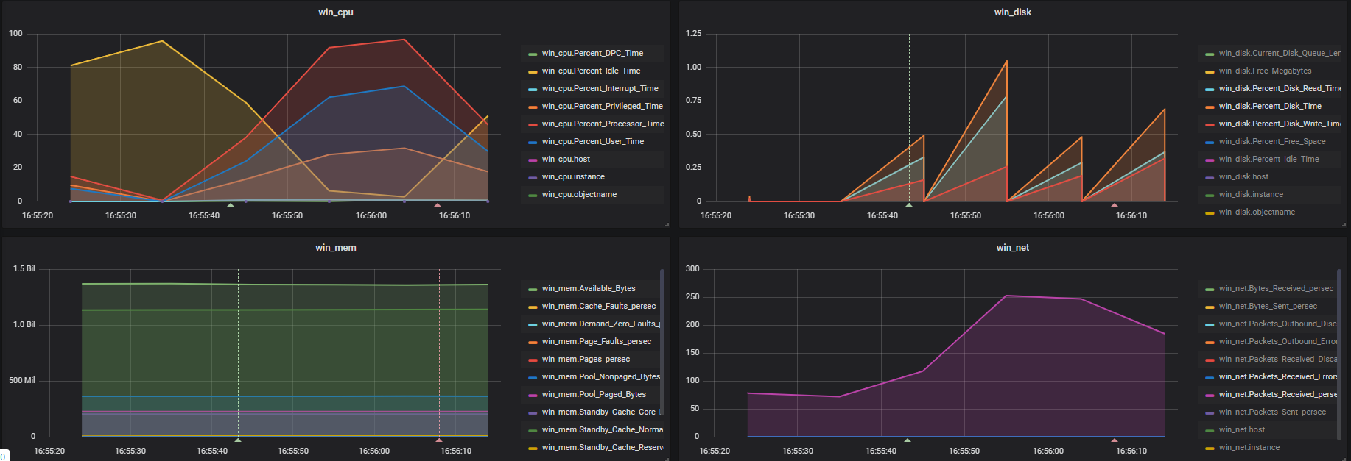

**Server Metrics of machine with which I load the Blog**

* ***JMeter run results from Grafana***

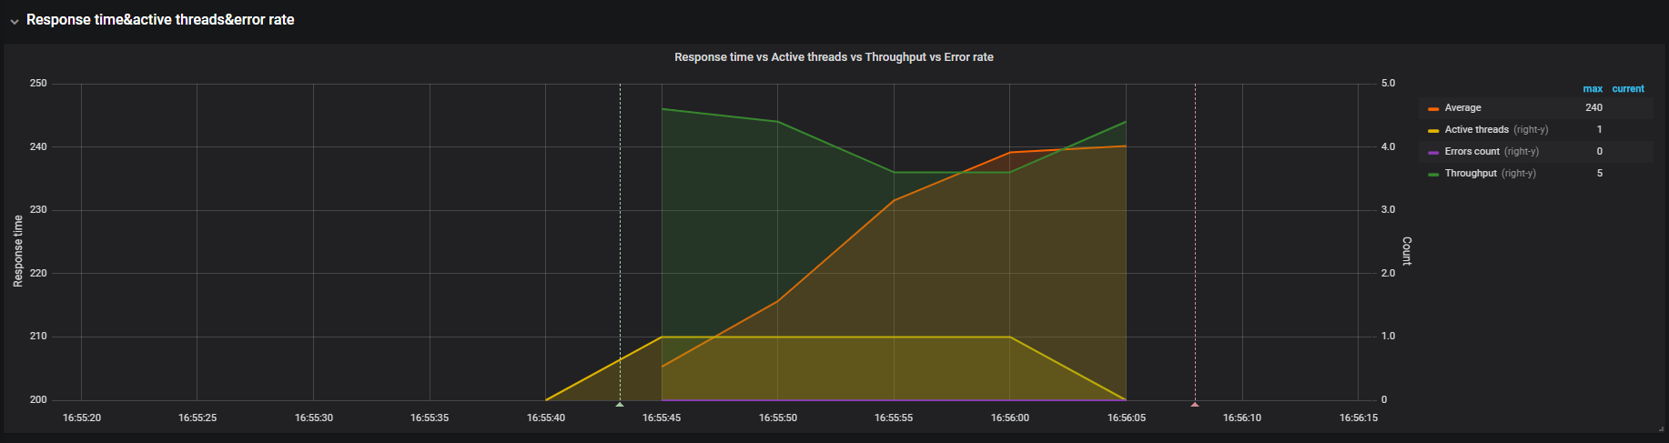

**Response time(avg) &Active threads & throughput**

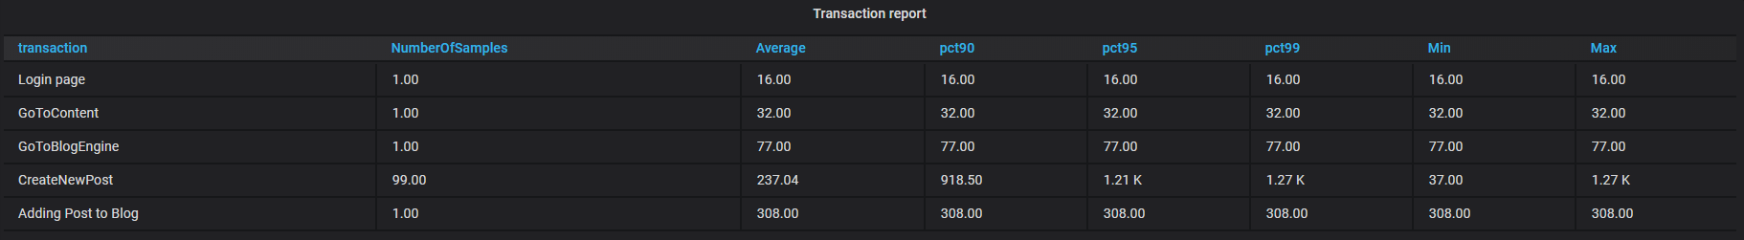

**Transaction report**

So generating 100 post by one user, has such parameters as 5requests per second and maximum value of response time is 240.

## Test run#2 – 1000 articles generation

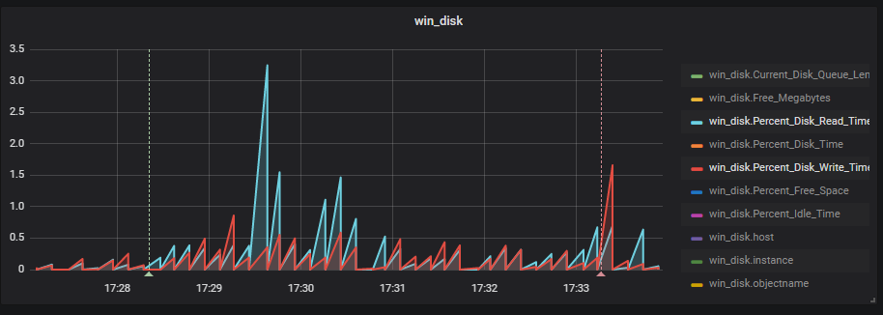

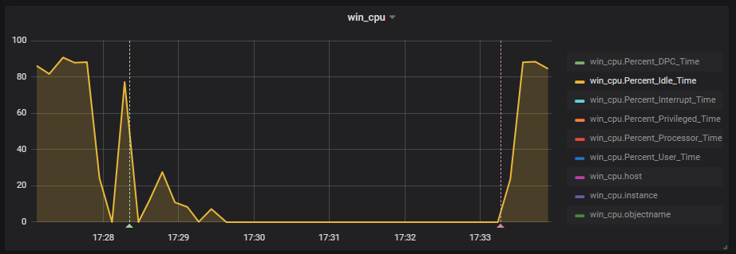

Percent Idle Time shows how free your system is now. So during the test system is free on 0%.

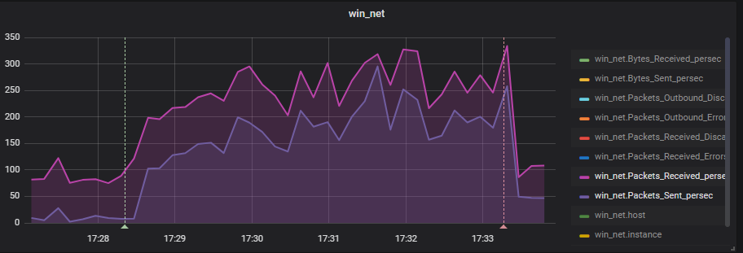

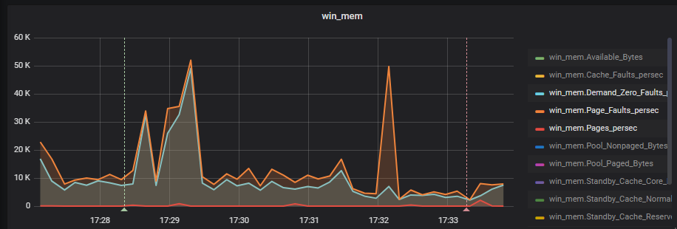

* ***JMeter run results from Grafana***

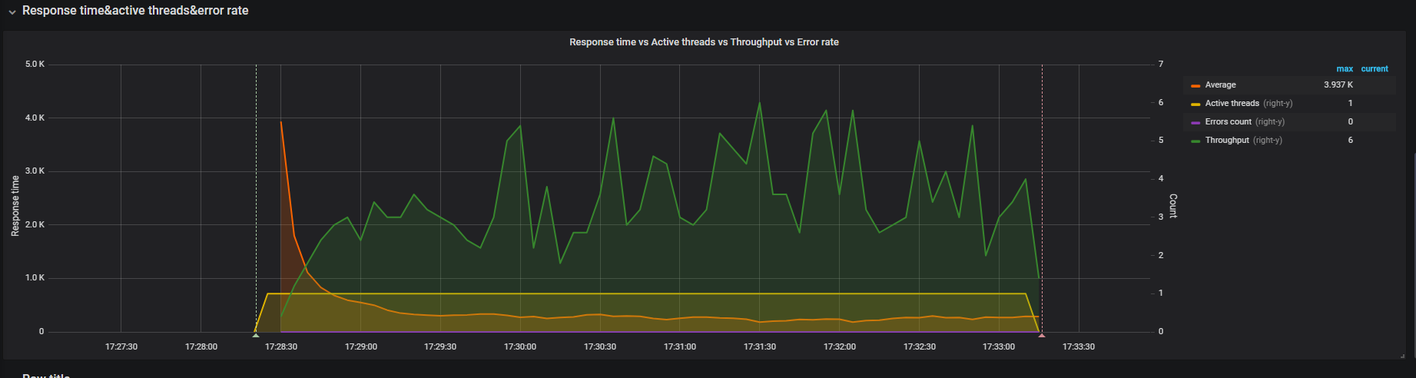

Throughput in comparison with first test this metric decreased.

## Test run#2 – 2000 articles generation

* ***JMeter run results from Grafana***

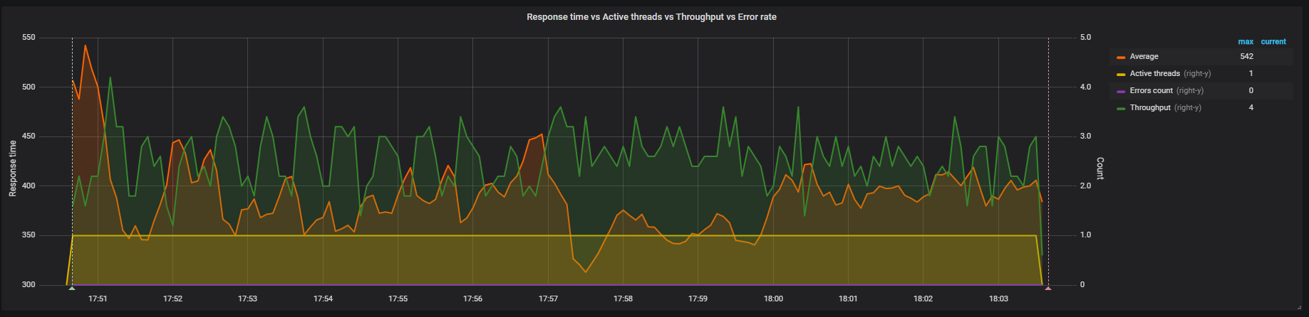

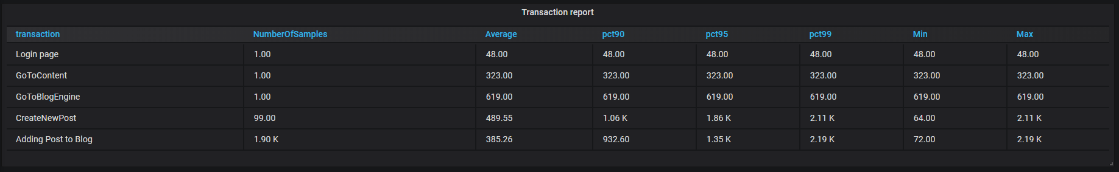

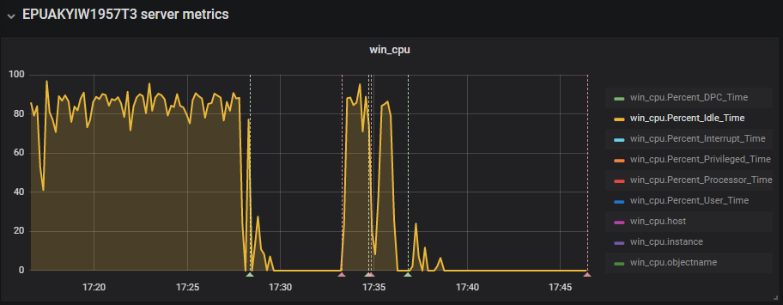

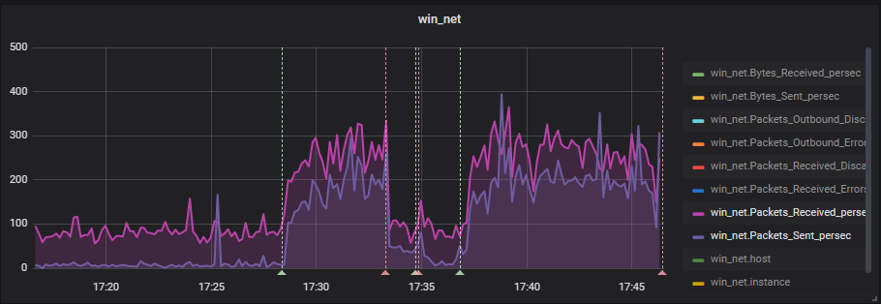

# Conclusion

With an increase in the number of posts, throughput decreases and response time grows.